FACULTY COLLEGE OF INFORMATION TECHNOLOGY

Database Systems - Project   
Inventory MANAGEMENT SYSTEM

**SUBMITTED BY:**

SYED ABBAS ALI KAZMI (BCSF20M023)

M.SHAZIL (BCSF20M030)

ASIM ALI (BCSF20M036)

**SUBMITTED TO**: PROF. ASIF SOHAIL

**Introduction to the working of the system**

# **Define Problems and Constraints**

The company **XYZ** has one of the **distributer** in Lahore , he has started the business throughout the country. His business has warehouse which stores the incoming products and supply the ordered products to the customers.

They have their own office , there they deal with customers and suppliers.

The distributer purchases products from company and then sale to those customers who have ordered for.This whole cycle is managed by employees, salespersons etc.

_______________

# **Define Objectives**

Our **objective** is to create the database for their business to keep detailed **record of all incoming/ outgoing** products.

This will store the records of all supplier and customers.

This system will also keep record of order for products and the company’s employees which will manage the orders. The employee will also assemble the products in warehouse and this record will also be stored.

_____________

### Entity – Relationship Diagram of system:

The following Entity-Relationship Diagram (ERD) represents the relationships of different entities in this database system   
  
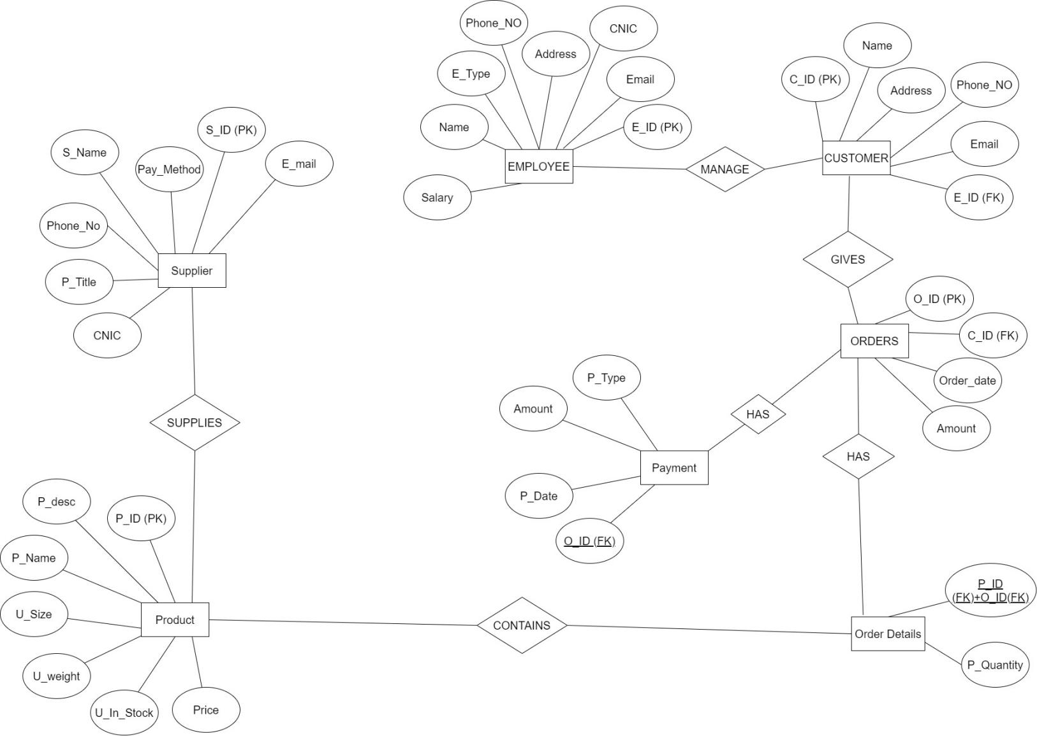

CONVERTING ERD MODEL INTO RELATIONAL MODEL:  
  
**CUSTOMER (** C_ID , Name , Address , Phone_NO , Email , E_ID (FK) )

**EMPLOYEE (** E_ID , Email , CNIC , Address , Phone_NO , E_Type **,** Name , Salary )   
**ORDER DETAIL (** O_ID (FK) + P_ID (FK) , P_Quantity )  
 **ORDERS** ( O_ID , C_ID , Order_Date ,Amount )   
**PAYMENT** (O_ID(FK) , Date , Amount , P_Type )  
**PRODUCT** (P_ ID , P_desc , P_Name , U_Size , U_weight , U_In_Stock ,Price)

**SUPPLIER** ( S_ID , S_Name , Phone_NO , Email ,CNIC , P_Title , Pay_Method )

CONVERTING RELATIONAL MODEL TO 3RD NORMAL FORM:

**CUSTOMER (** C_ID , Name , Address , Phone_NO , Email,E_ID (FK) )

**EMPLOYEE (** E_ID , Email , CNIC , Address , Phone_NO , E_Type **,** Name , Salary )   
**ORDER DETAIL (** O_ID (FK) + P_ID (FK) , P_Quantity )  
 **ORDERS** ( O_ID , C_ID , Order_Date ,Amount )   
**PAYMENT** ( O_ID(FK) , Date , Amount , P_Type )

**PRODUCT** (P_ ID , P_desc , P_Name , U_Size , U_weight , U_In_Stock ,Price )

**SUPPLY DETAILS** ( P_ID (FK) + S_ID , Pay_Method )

# **SUPPLIER** ( S_ID , S_Name , Phone_NO , Email ,CNIC , P_Title ) Untitled Diagram (1) Connectivity Table

|  |  |  |  |
| --- | --- | --- | --- |
| **ENTITY** | **RELATIONSHIP** | **CONNECTIVITY** | **ENTITY** |
| CUSTOMER | MANAGE | M:0 || 1:1 | EMPLOYEE |
| EMPLOYEE | TAKES | M:1 || 1:0 | ORDERS |
| ORDER DETAIL | CONTAINS | 1:1 || M:1 | PRODUCT |
| SUPPLY DETAIL | UPDATES | M:1 || 1:1 | SUPPLIER |
| SUPPLY DETAIL | SUPPLIES | M:1 || 1:1 | PRODUCT |
| CUSTOMER | GIVES | 1:1 || M:0 | ORDER |
| ORDERS | HAS | 1:1 || 1:1 | ORDER DETAIL |
| ORDERS | HAS | 1:1 || 1:1 | PAYMENT |

**Table Name: CUSTOMER**

|  |  |  |  |
| --- | --- | --- | --- |
| **Attribute** | **Data Type** | **Size** | **Constraints** |
| C_ID | NUMBER | 4 | PRIMARY KEY |
| Name | VARCHAR2 | 20 | NOT NULL |
| Address | VARCHAR2 | 50 | NOT NULL |
| Phone_NO | NUMBER | 13 | NOT NULL |
| Email | VARCHAR2 | 20 | NOT NULL |
| E_ID | NUMBER | 4 | FOREIGN KEY REFERANCES EMPLOYEE |

**Table Name: EMPLOYEE**

|  |  |  |  |
| --- | --- | --- | --- |
| **Attribute** | **Data Type** | **Size** | **Constraints** |
| E_ID | NUMBER | 4 | PRIMARY KEY |
| Email | VARCHAR2 | 20 | NOT NULL |
| CNIC | NUMBER | 13 | NOT NULL |
| Address | VARCHAR2 | 50 | NOT NULL |
| Phone_NO | NUMBER | 13 | NOT NULL |
| E_Type | VARCHAR2 | 15 | NOT NULL |
| Name | VARCHAR2 | 20 | NOT NULL |
| Salary | NUMBER | 8 | NOT NULL |

**Table Name: ORDERS**

|  |  |  |  |
| --- | --- | --- | --- |
| **Attribute** | **Data Type** | **Size** | **Constraints** |
| O_ID | NUMBER | 4 | PRIMARY KEY |
| C_ID | NUMBER | 4 | FOREIGN KEY REFERANCES CUSTOMER |
| Order_Date | DATE |  | NOT NULL |

**Table Name: ORDER DETAIL**

|  |  |  |  |
| --- | --- | --- | --- |
| **Attribute** | **Data Type** | **Size** | **Constraints** |
| O_ID | NUMBER | 4 | PRIMARY KEY, FK REFERANCES ORDERS |
| P_ID | NUMBER | 4 | PRIMARY KEY, FK REFERANCES PRODUCT |
| P_Quantity | NUMBER | 5 | NOT NULL |

**Table Name: PAYMENT**

|  |  |  |  |
| --- | --- | --- | --- |
| **Attribute** | **Data Type** | **Size** | **Constraints** |
| O_ID | NUMBER | 4 | PRIMARY KEY , UNIQUE |
| P_Date | DATE |  | NOT NULL |
| Amount | NUMBER | 8 | NOT NULL |
| P_Type | CHAR | 2 | NOT NULL |

**Table Name: PRODUCT**

|  |  |  |  |
| --- | --- | --- | --- |
| **Attribute** | **Data Type** | **Size** | **Constraints** |
| P_ID | NUMBER | 4 | PRIMARY KEY |
| P_desc | VARCHAR2 | 200 | NONE |
| P_Name | VARCHAR2 | 20 | NOT NULL |
| U_Size | NUMBER | 4 | NOT NULL |
| U_weight | NUMBER | 4 | NOT NULL |
| U_In_Stock | NUMBER | 6 | NOT NULL |
| Price | NUMBER | 5 | NOT NULL |

**Table Name: SUPPLY DETAILS**

|  |  |  |  |
| --- | --- | --- | --- |
| **Attribute** | **Data Type** | **Size** | **Constraints** |
| P_ID | NUMBER | 4 | PRIMARY KEY ,FK REFERANCES PRODUCT |
| S_ID | NUMBER | 4 | PRIMARY KEY ,FK REFERANCES SUPPLIER |
| Pay_Method | VARCHAR2 | 10 | NOT NULL |

**Table Name: SUPPLIER**

|  |  |  |  |
| --- | --- | --- | --- |
| **Attribute** | **Data Type** | **Size** | **Constraints** |
| S_ID | NUMBER | 4 | PRIMARY KEY |
| S_Name | VARCHAR2 | 20 | NOT NULL |
| Phone_NO | NUMBER | 13 | NOT NULL |
| Email | VARCHAR2 | 20 | NOT NULL |
| CNIC | VARCHAR2 | 13 | NOT NULL |
| P_Title | VARCHAR2 | 20 | NOT NULL |

**6. CREATE TABLE statements for all the relations of your system.**

**CUSTOMER:**

CREATE TABLE CUSTOMER(

C_ID NUMBER(4) ,

Name VARCHAR2(20) NOT NULL,

Address VARCHAR2(50) NOT NULL,

Phone_No NUMBER(13) NOT NULL,

Email VARCHAR2(20) NOT NULL,

E_ID NUMBER (4) NOT NULL,

CONSTRAINT CUST_P PRIMARY KEY (C_ID),

CONSTRAINT CUST_F FOREIGN KEY(E_ID) REFERENCES Employee(E_ID)

);

**EMPLOYEE:**

CREATE TABLE EMPLOYEE(

E_ID NUMBER(4) ,

Email VARCHAR2(20) NOT NULL,

CNIC NUMBER(13) NOT NULL,

Address VARCHAR2(50) NOT NULL,

Phone_NO NUMBER (13) NOT NULL,

E_Type VARCHAR2(15) NOT NULL,

Name VARCHAR2(20) NOT NULL,

Salary NUMBER(8) NOT NULL,

CONSTRAINT E_P PRIMARY KEY(E_ID)

);

**ORDERS:**

CREATE TABLE ORDERS(

O_ID NUMBER(4),

C_ID NUMBER(4) NOT NULL,

Order_Date DATE NOT NULL,

CONSTRAINT O_P PRIMARY KEY(O_ID),

CONSTRAINT O_F FOREIGN KEY(C_ID) REFERENCES CUSTOMER(C_ID)

);

**PRODUCT**

CREATE TABLE PRODUCT(

P_ID NUMBER(4) ,

P_Desc VARCHAR2(200),

P_Name VARCHAR2(20) NOT NULL,

U_Size NUMBER(4) NOT NULL,

U_weight NUMBER(4) NOT NULL,

U_In_Stock NUMBER(6) NOT NULL ,

Price NUMBER(5) NOT NULL

CONSTRAINT P_P PRIMARY KEY(P_ID)

);

**ORDER_DETAIL**

CREATE TABLE ORDER_DETAIL(

O_ID NUMBER(4) ,

P_ID NUMBER(4) ,

P_Quantity VARCHAR2(5) NOT NULL,

CONSTRAINT OD_P PRIMARY KEY (O_ID, P_ID),

CONSTRAINT OD_F2 FOREIGN KEY(O_ID) REFERENCES ORDERS(O_ID),

CONSTRAINT OD_F3 FOREIGN KEY(P_ID) REFERENCES PRODUCT(P_ID)

);

**PAYMENT**

CREATE TABLE PAYMENT(

O_ID NUMBER(4) UNIQUE,

P_Date DATE NOT NULL,

Amount NUMBER(8) NOT NULL ,

P_Type CHAR(2) NOT NULL,

CONSTRAINT O_P PRIMARY KEY(O_ID)

);

**SUPPLIER**

CREATE TABLE SUPPLIER(

S_ID NUMBER(4) PRIMARY KEY,

S_Name VARCHAR2(20) NOT NULL,

Phone_NO NUMBER(13) NOT NULL ,

Email VARCHAR2(20) NOT NULL,

CNIC VARCHAR2(13) NOT NULL,

P_Title VARCHAR2(20) NOT NULL

);

**SUPPLIER DETAIL**

CREATE TABLE SUPPLIER_DETAIL(

P_ID NUMBER(4) ,

S_ID NUMBER(4),

Pay_Method VARCHAR2(10) NOT NULL ,

CONSTRAINT SD_P PRIMARY KEY (P_ID,S_ID),

CONSTRAINT SD_F1 FOREIGN KEY(P_ID) REFERENCES PRODUCT(P_ID),

CONSTRAINT SD_F2 FOREIGN KEY(S_ID) REFERENCES SUPPLIER(S_ID)

);

**INSERTION QUERIES**

**EMPLOYEE**

INSERT INTO EMPLOYEE

VALUES(001,'shazil123@gmail.com',3520257929019, 'house 1 lahore ', 0333312343, ‘SALESPERSON’, 'shazil',10000)

INSERT INTO EMPLOYEE

VALUES(2,'abbas123@gmail.com',3520257929029, 'house 2 lahore ', 0333322343, ‘MANAGER’, 'abbas',100000)

INSERT INTO EMPLOYEE

VALUES(3,'asim123@gmail.com',3520257929039, 'house 3 lahore ', 0333332343, ‘SALESPERSON’, 'asim',120000)

**CUSTOMER**

INSERT INTO CUSTOMER

VALUES(100,'ALI', 'house 100 lahore ', 0233312343 , 'ALI1@GMAIL.COM',1)

INSERT INTO CUSTOMER

VALUES(101,'ALI1', 'house 101 lahore ', 0243312343 , 'ALI2@GMAIL.COM',1)

INSERT INTO CUSTOMER

VALUES(102,'ALI2', 'house 102 lahore ', 0253312343 , 'ALI3@GMAIL.COM',1)

INSERT INTO CUSTOMER

VALUES(102,'ALI2', 'house 102 lahore ', 0253312343 , 'ALI3@GMAIL.COM',1)

INSERT INTO CUSTOMER

VALUES(102,'ALI2', 'house 102 lahore ', 0253312343 , 'ALI3@GMAIL.COM',1)

INSERT INTO CUSTOMER

VALUES(103,'ALI3', 'house 103 lahore ', 02543312343 , 'ALI3@GMAIL.COM',3)

**ORDERS**

INSERT INTO ORDERS

VALUES(1001,'100', '01/06/2022')

INSERT INTO ORDERS

VALUES(1002,'101', '02/06/2022')

INSERT INTO ORDERS

VALUES(1003,'102', '03/06/2022')

INSERT INTO ORDERS

VALUES(1004,'103', '04/06/2022')

**PRODUCT**

INSERT INTO PRODUCT

VALUES(50,'100% Original 5 Amp Power Supply 12V','Amp Power Supply',20,10,100 )

INSERT INTO PRODUCT

VALUES(51,'90% Original 5 Amp Power Supply 10V','Amp Power Supply2',20,10,100 )

INSERT INTO PRODUCT

VALUES(52,'80% Original 5 Amp Power Supply 8V','Amp Power Supply3',20,10,100 )

**ORDER_DETAILS**

INSERT INTO ORDER_DETAIL

VALUES(1001,50, 50 )

INSERT INTO ORDER_DETAIL

VALUES(1002,51, 50 )

INSERT INTO ORDER_DETAIL

VALUES(1003,51, 30 )

INSERT INTO ORDER_DETAIL

VALUES(1004,52, 70 )

**PAYMENT**

INSERT INTO PAYMENT

VALUES(1001,'01/02/2020', 500 ,'Rs')

INSERT INTO PAYMENT

VALUES(1002,'02/02/2020', 750 ,'Rs')

INSERT INTO PAYMENTselect * from payment

VALUES(1003,'03/02/2020', 1500 ,'Rs')

INSERT INTO PAYMENT

VALUES(1004,'04/02/2020', 1400 ,'Rs' )

**SUPPLIER**

INSERT INTO SUPPLIER

VALUES(2001,'HAFIZ',03334247932,'HAFIZ@GMAIL.COM',3520202686876,'Amp Power Supply' )

INSERT INTO SUPPLIER

VALUES(2002,'AHMED',03334247982,'AHMED@GMAIL.COM',35202086877,'Amp Power Supply2' )

INSERT INTO SUPPLIER

VALUES(2003,'SUNNY',0334247983,'SUNNY@GMAIL.COM',3520202686878,'Amp Power Supply3' )

**SUPPLIER DETAIL**

INSERT INTO SUPPLIER_DETAIL

VALUES(50,2001,'CASH' )

INSERT INTO SUPPLIER_DETAIL

VALUES(51,2002,'CASH' )

INSERT INTO SUPPLIER_DETAIL

VALUES(52,2003,'CREDIT ‘)  
Q-7 ASSOCIATION AMONG RELATIONAL DATA MODEL :

|  |  |  |  |  |  |
| --- | --- | --- | --- | --- | --- |
| **CUSTOMER** | C_ID | Name | Address | Phone_NO | Email |

|  |  |  |  |  |  |  |  |  |
| --- | --- | --- | --- | --- | --- | --- | --- | --- |
| **EMPLOYEE** | E_ID | Email , | CNIC | Address | Phone_NO | E_Type | Name | Salary |

|  |  |  |
| --- | --- | --- |
| **ORDER DETAIL** | O_ID(FK) + P_ID FK) | P_Quantity |

|  |  |  |  |
| --- | --- | --- | --- |
| **ORDER** | O_ID | C_ID | Order_Date |

|  |  |  |  |  |  |
| --- | --- | --- | --- | --- | --- |
| **PAYMENT** | Pay_ID | Date | Amount | P_Type | O_ID |

|  |  |  |  |  |  |  |
| --- | --- | --- | --- | --- | --- | --- |
| **PRODUCT** | P_ ID | P_desc | P_Name | U_Size | U_weight | U_In_Stock |

|  |  |  |  |
| --- | --- | --- | --- |
| **SUPPLY DETAILS** | P_ID (FK) + S_ID | U_In_Stock | Pay_Method |

|  |  |  |  |  |  |  |
| --- | --- | --- | --- | --- | --- | --- |
| **SUPPLIER** | S_ID | S_Name | Phone_NO | Email | CNIC | P_Title |

**8. Select statement for at least five common reports to be generated by the system.**

**1)**

WRITE A QUERY TO SELECT THE NAME OF THE PRODUCT TAKEN BY CUSTOMER (CID = 101)

SELECT P_NAME FROM PRODUCT WHERE P_ID = (

SELECT P_ID FROM ORDER_DETAIL WHERE O_ID =(

SELECT O_ID FROM ORDERS WHERE C_ID = (

SELECT C_ID FROM CUSTOMER WHERE C_ID = 101)))

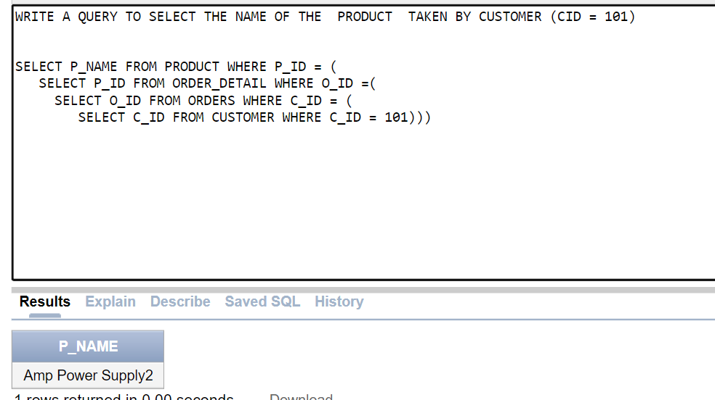

**2)WRITE A QUERY TO DISPLAY THE NAME OF THAT EMPLOYEE AND INCREASE HIS SALARAY BY 20% IF HE HAS MANGED MORE THAN 2 CUSTOMERS**

SELECT * FROM EMPLOYEE

SELECT * FROM CUSTOMER

SELECT * FROM ORDERS

SELECT * FROM ORDER_DETAIL

SELECT * FROM PRODUCT

SELECT E_ID , NAME , SALARY+ SALARY*0.1 "SALARY" FROM EMPLOYEE WHERE E_ID =

( SELECT E_ID FROM CUSTOMER

GROUP BY E_ID

HAVING COUNT(E_ID)>2)

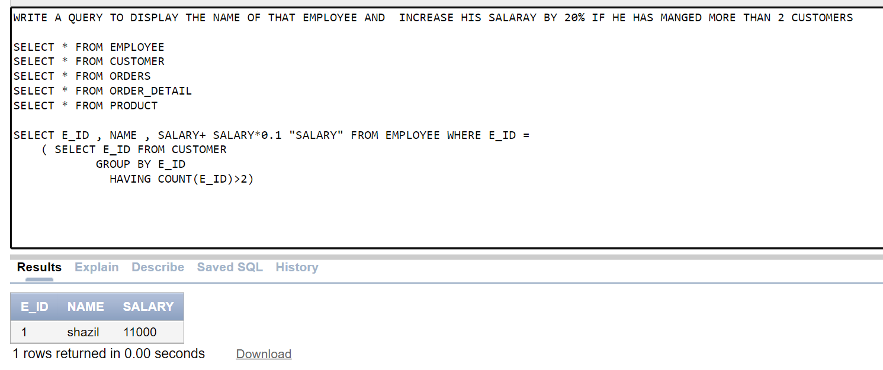

**3)WRITE A QUERY TO RETRIEVE THE the name and contact information of suppliers who supply a product with id '51'**

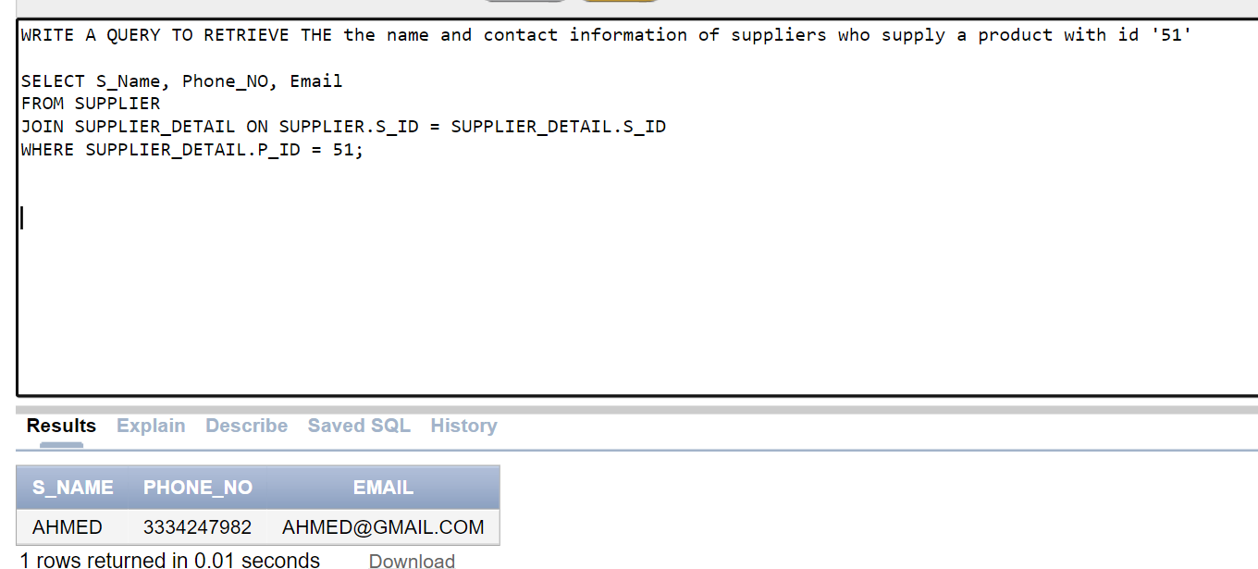

**4)WRITE A QUERY To retrieve the name and total amount of payments made for each order:**

SELECT O.O_ID, CUSTOMER.Name, SUM(PAYMENT.Amount)

FROM ORDERS O

JOIN CUSTOMER ON O.C_ID = CUSTOMER.C_ID

JOIN PAYMENT ON O.O_ID = PAYMENT.O_ID

GROUP BY O.O_ID, CUSTOMER.Name;

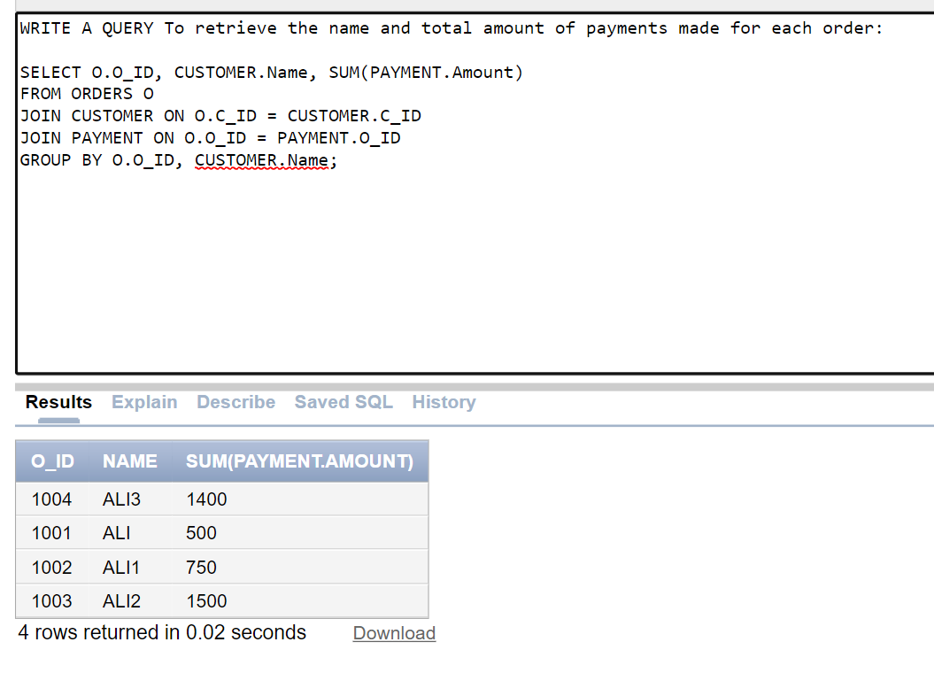

**5)WRITE A QUERY To retrieve the details of an order with id 1004**

SELECT *

FROM ORDERS

JOIN ORDER_DETAIL ON ORDERS.O_ID = ORDER_DETAIL.O_ID

JOIN PRODUCT ON ORDER_DETAIL.P_ID = PRODUCT.P_ID

WHERE ORDERS.O_ID = 1004;

